Sample Social Media Posts - Twitter

Make your voice count!
Tell your Senator and Representative how 21st CCLC supports Community Schools in Illinois

As Congress moves to reauthorize the Elementary and Secondary Education Act (ESEA), also known as No Child Left Behind, it is critical to students, families and communities in Illinois that the 21st Century Community Learning Center (CCLC) program is maintained as a separate and specific federal funding stream for school and community partnerships that provide vital afterschool and out-of-school time programs.

Rep. John Kline (R-MN), who leads the House Education and the Workforce Committee, is moving towards a vote on the House rewrite of ESEA soon. This debate provides the perfect opportunity for community school advocates to take action and support funding for afterschool programs. With significant cuts being proposed to dedicated afterschool and 21st CCLC funding in both the House and Senate, community schools are expected to respond to increasing needs with fewer resources; affecting thousands of low-income students and their families in urban, suburban, and rural communities in Illinois and across the country.

What can you do? We are asking community school stakeholders to use social media to share with their Senators and Representatives why 21st CCLC is important for students and families in our state. You can make an even greater impact by sharing this action with your friends and family too! It’s simple, and only takes 140 characters!

Here are a few Tweets to get you started:
(Be sure to insert your Representative’s handle from page 2)

- #21CCLC provides #afterschool programs to low-income students & families in #IL. @InsertRepHandle, support #communityschools #Invest3to6!

- @InsertRepHandle -1 Million kids in #IL could benefit from an #afterschool program. #Invest3to6 so #communityschools can meet this demand!

- @InsertRepHandle, #Invest3to6 to keep kids safe and engaged in #afterschool programs. #Communityschools can't afford #21CCLC cuts.

- In #IL, 65,000 students & 11,000 adults count on #communityschools each day.@InsertRepHandle, #Invest3to6 - don't cut #21CCLC funding!

- 84% of parents support public funding for #afterschool programs.@InsertRepHandle, keep #communityschools strong in #IL! #Invest3to6!

- #21CCLC allows #communityschools to [personalize this Tweet!].@InsertRepHandle, #Invest3to6!

These sample tweets include hashtags (#) that connect the work of community schools and afterschool supporters here in Illinois, to a greater national movement that has the potential to make a real impact. Join us and be part of a national campaign to support afterschool and 21st CCLC funding!

Thanks for your support,
The Federation for Community Schools Team

Find your Senator and Representative on Twitter

House
District | Name | Twitter Handle
1 | Bobby Rush | @RepBobbyRush
2 | Robin Kelly | @RepRobinKelly
3 | Dan Lipinski | @RepLipinski
4 | Luis Gutiérrez | @RepGutierrez
5 | Michael Quigley | @RepMikeQuigley
6 | Peter Roskam | @PeterRoskam
7 | Danny Davis | @RepDannyDavis
8 | Tammy Duckworth | @RepDuckworth
9 | Jan Schakowsky | @Janschakowsky
10 | Robert Dold | @RepDold
11 | Bill Foster | @RepBillFoster
12 | Mike Bost | @RepBost
13 | Rodney Davis | @RodneyDavis
14 | Randy Hultgren | @RepHultgren
15 | John Shimkus | @RepShimkus
16 | Adam Kinzinger | @RepKinzinger
17 | Cheri Bustos | @RepCheri
18 | vacant
Senate
 | Dick Durbin | @SenatorDurbin
 | Mark Kirk | @SenatorKirk

Examples from our 2014 Community Schools Forum

Harnessing the Power of Partnership to Promote Equity through Community Schools
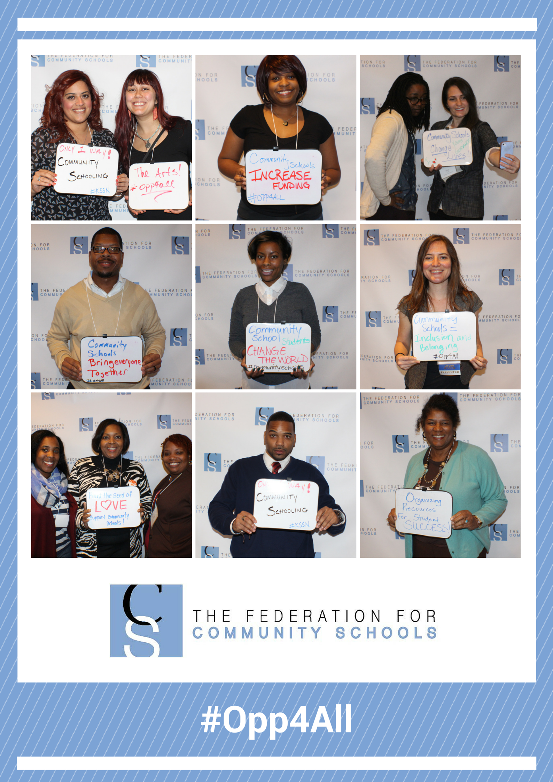

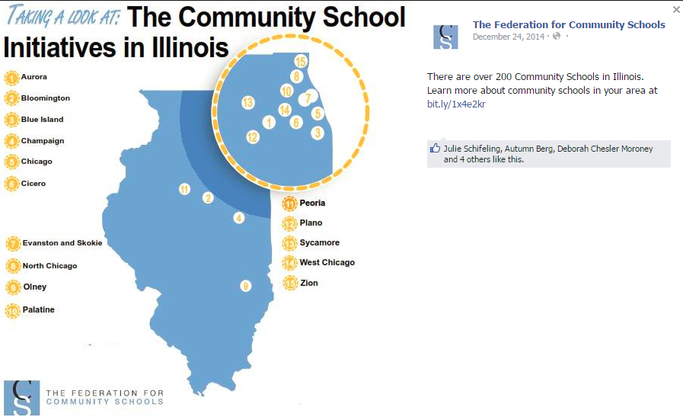
Community Schools in Illinois

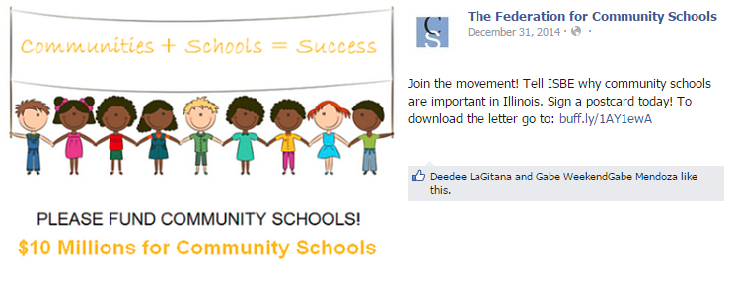
$10 Million for Community Schools Campaign

